41.34: a) For large values of n, the inner electrons will completely shield the nucleus, so 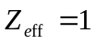 and the ionization energy would be 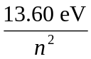.
b)

c) Similarly for n = 650, 